# CREATE A DATABASE IN CLOUDANT DB

|  |  |
| --- | --- |
| **TEAM ID** | PNT2022TMID43251 |
| **PROJECT NAME** | Smart waste management system for  metropolitan cities |

**Create A Database In Cloudant DB.**

**Aim:** To create a database in Cloudant DB to store location data.

# Steps followed:

* Logged in to IBM Cloud account.
* Navigated to `. /resources`.
* Clicked on the “Create Resource +” button.
* Searched for “Cloudant”.
* Chose the “Lite Version” and clicked on “Create”.
* Clicked on Launch Dashboard
* Clicked on “Create Database”. Entered “meowman” as the database name and the “Non-partitioned” option.
* The database “meowman” was created successfully.

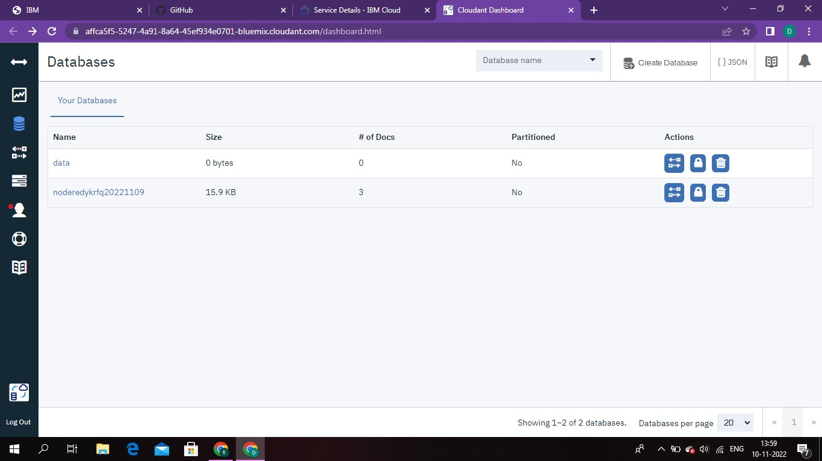

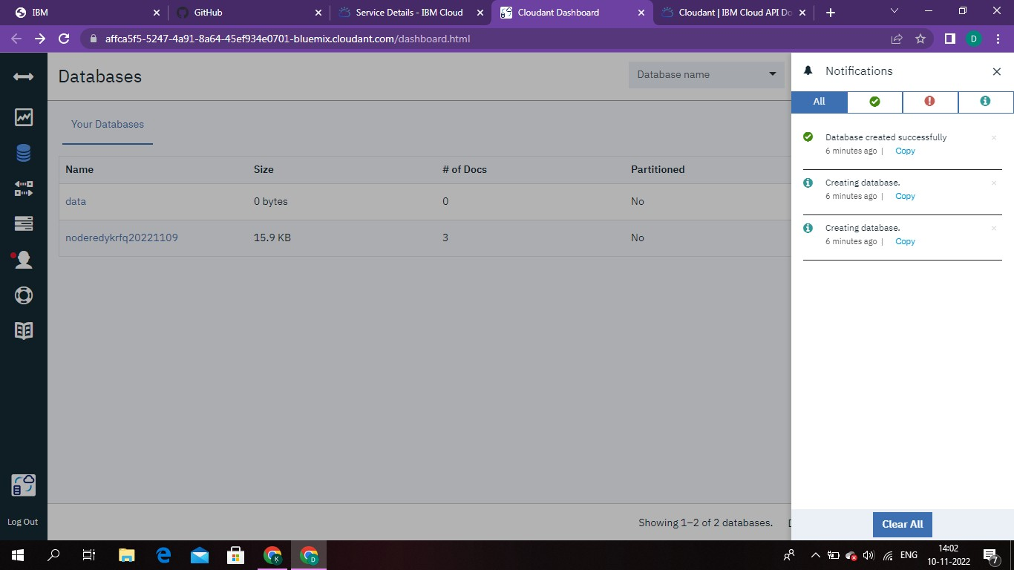

# Result:

A database to store the location data was created successfully on Cloudant DB.